Nama : Muhammad Adil Imamul Haq Mubarak

NIM : 202311008

Matkul : AI

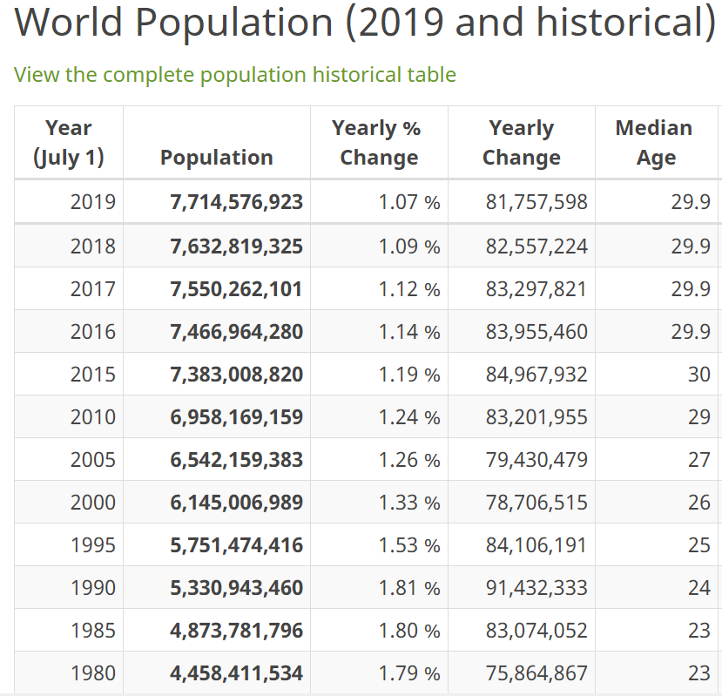

Code :

import numpy as np

import matplotlib.pyplot as plt

from sklearn.linear_model import LinearRegression

X = np.array([[1980], [1985], [1990], [1995], [2000], [2005], [2010], [2015]])

y = np.array([23, 23, 24, 25, 26, 27, 29, 30])

model = LinearRegression()

model.fit(X, y)

y_pred = model.predict(X)

print(f'Koefisien: {model.coef_[0]}')

print(f'Intercept: {model.intercept_}')

plt.scatter(X, y, color='blue', label='Data Asli')

plt.plot(X, y_pred, color='red', label='Regresi Linear')

plt.xlabel('Tahun')

plt.ylabel('Umur Rata-rata')

plt.title('Regresi Linear Sederhana')

plt.legend()

plt.show()

Hasil :

